USING SPI IN ARDUINO TO COMMUNICATE BETWWEEN KEYPAD IN MASTER ARDUINO AND I2C LCD IN SLAVE ARDUINO

A microcontroller makes use of a broad range of protocols to communicate with various sensors and modules. Serial communication, which has a broad range of wireless and wired communication methods, is the most frequently used type of communication. Sending data bits sequentially, one at a time, over a bus or communication channel is known as serial transmission. Serial transmission methods come in a wide variety, including UART, CAN, USB, I2C, and SPI. A microcontroller makes use of a broad range of protocols to communicate with various sensors and modules. Serial communication, which has a broad range of wireless and wired communication methods, is the most frequently used type of communication.
Serial communication is the act of sequentially sending data bits, one at a time, over a bus or communication channel. There are many different serial transmission protocols, including UART, CAN, USB, I2C, and SPI.

Operation of SPI
A SPI uses four lines for master-slave transmission. A SPI can have more than one slave but only one owner. Typically, a microcontroller serves as the master, and sensors, ADCs, DACs, LCDs, etc. can serve as servants.

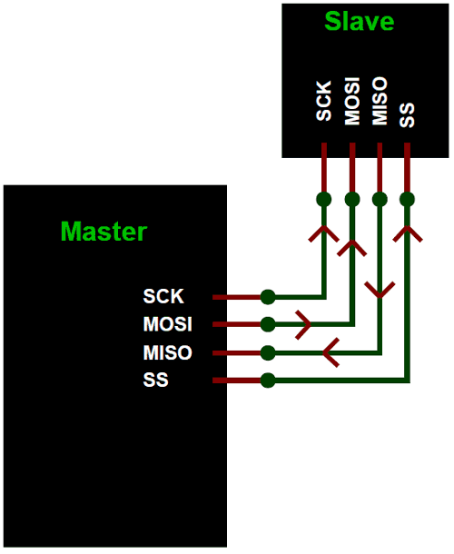

SPI four lines MISO, MOSI, SS, and CLK
- MISO - The Slave line for sending data to the master.
- MOSI - The Master line for sending data to the peripherals.
- SCK - The clock pulses which synchronize data transmission generated by the master arduino.
- SS –Master arduino can use this pin to enable and disable specific devices.
The Slave Select (SS) pin of the necessary device must be set to LOW in order for the slave to begin contact with the master. It ignores the teacher while high. This enables you to share the MISO, MOSI, and CLK lines of the master between numerous SPI devices. As seen in the image above, there are four slaves. The SCLK, MISO, and MOSI are all shared connections to the master, and the SS of each slave is connected individually to each of the master's SS pins. The required SS pin must be set to LOW in order for a master to interact with a slave.
MOSI | PIN 11
SS | PIN 10
MISO | PIN 12
SCK | PIN13
COMPONENTS FOR THE PROJECT
Arduino UNO
Keypad
Breadboard
I2C lcd Display
KEYPAD AND I2C LCD CONNECTION
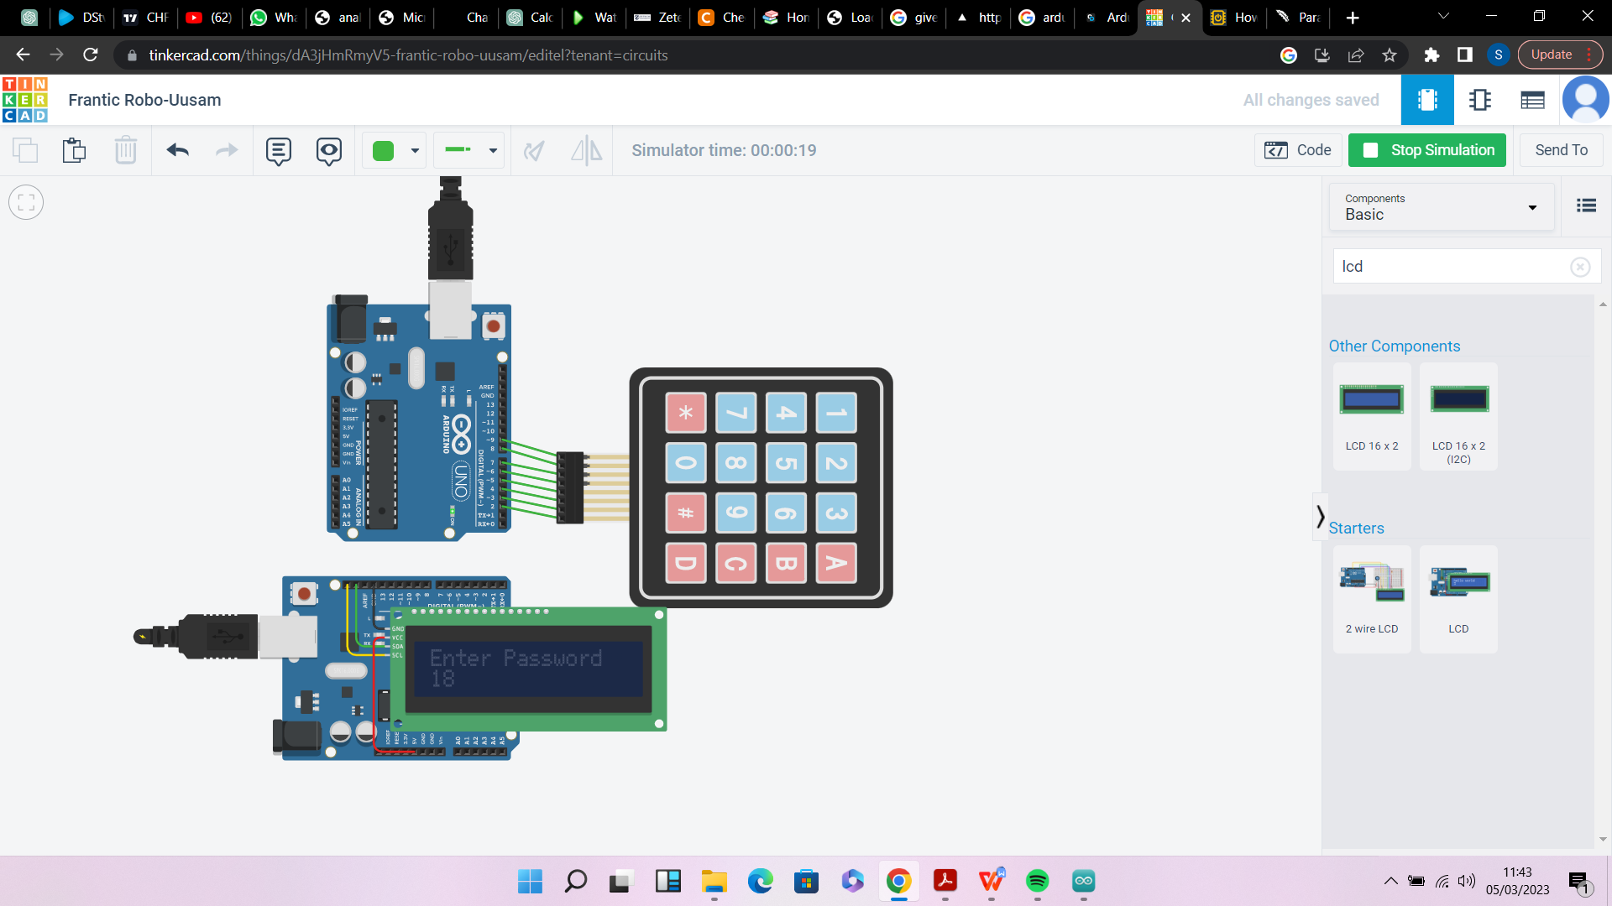

THE CODE FOR A 4X4 KEYPAD SETUP TEST
#include <Keypad.h>

const byte ROWS = 4;
const byte COLS = 4;

char hexaKeys[ROWS][COLS] = {
{'1', '2', '3', 'A'},
{'4', '5', '6', 'B'},
{'7', '8', '9', 'C'},
{'*', '0', '#', 'D'}
};

byte rowPins[ROWS] = {9, 8, 7, 6};
byte colPins[COLS] = {5, 4, 3, 2};

Keypad customKeypad = Keypad(makeKeymap(hexaKeys), rowPins, colPins, ROWS, COLS);

void setup(){
Serial.begin(9600);
}

void loop(){
char customKey = customKeypad.getKey();

if (customKey){
Serial.println(customKey);
}
}

THE CODE FOR I2C LCD SETUP TEST
// C++ code
//
#include <Adafruit_LiquidCrystal.h>

int seconds = 0;

Adafruit_LiquidCrystal lcd_1(0);

void setup()
{
lcd_1.begin(16, 2);

lcd_1.print("Enter Password");
}

void loop()
{
lcd_1.setCursor(0, 1);
lcd_1.print(seconds);
lcd_1.setBacklight(1);
delay(500); // Wait for 500 millisecond(s)
lcd_1.setBacklight(0);
delay(500); // Wait for 500 millisecond(s)
seconds += 1;}

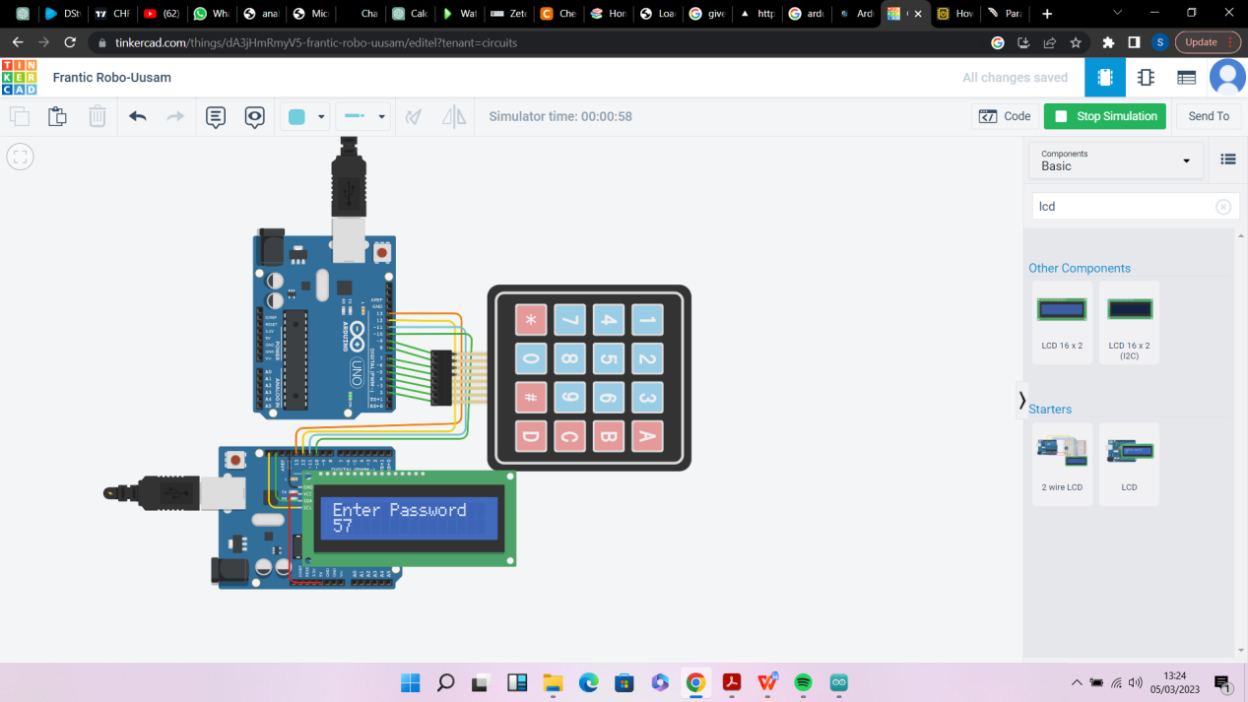

MASTER CODE
#include <Wire.h>
#include <Keypad.h>
#include <SPI.h>

char Data[Password_Length];
char Master[Password_Length] = "SAMCY";
byte data_count = 0, master_count = 0;
bool Pass_is_good;
char customKey;

const byte ROWS = 4;
const byte COLS = 4;

char hexaKeys[ROWS][COLS] = {
{'1', '2', '3', 'A'},
{'4', '5', '6', 'B'},
{'7', '8', '9', 'C'},
{'*', '0', '#', 'D'}
};

byte rowPins[ROWS] = {9, 8, 7, 6};
byte colPins[COLS] = {5, 4, 3, 2};

Keypad customKeypad = Keypad(makeKeymap(hexaKeys), rowPins, colPins, ROWS, COLS);
LiquidCrystal_I2C lcd(0x21, 16, 2);

void setup(){
lcd.init();
lcd.backlight();
Serial.begin(115200);
SPI.begin();
SPI.setClockDivider(SPI_CLOCK_DIV8);
digitalWrite(SS,HIGH);
}

void loop(){

lcd.setCursor(0,0);
lcd.print("Enter Password:");

customKey = customKeypad.getKey();
if (customKey){
Data[data_count] = customKey;
lcd.setCursor(data_count,1);
lcd.print(Data[data_count]);
data_count++;

}

}

void clearData(){
while(data_count !=0){
Data[data_count--] = 0;
}
return;
}

SLAVE CODE

Slave Arduino Code:
#include<SPI.h>
volatile boolean received;

volatile byte Slavereceived,Slavesend;

int buttonvalue;

int x;

void setup()

{

Serial.begin(115200);

pinMode(MISO,OUTPUT); //Sets MISO as OUTPUT (Have to Send data to Master IN

SPCR |= _BV(SPE); //Turn on SPI in Slave Mode

received = false;

SPI.attachInterrupt(); //Interuupt ON is set for SPI commnucation

}

ISR (SPI_STC_vect) //Inerrrput routine function

{

Slavereceived = SPDR; // Value received from master if store in variable slavereceived

received = true; //Sets received as True

}

void loop()

{ if(received)
{

if(data_count == Password_Length-1){
lcd.clear();

if(!strcmp(Data, Master)){
lcd.print("Correct");
}
else{
lcd.print("Incorrect");
delay(1000);
}
lcd.clear();
clearData();

Slavesend=x;

SPDR = Slavesend; //Sends the x value to master via SPDR

delay(1000);

}

}

